QUARTER TWO

Multiplying and Dividing Rational Expressions-L21

Look out for division problems. Everyone keeps saying keep, change, flip, or, keep, change, change, if it works keep doing that.
If that’s confucing, try calling it what it is, it may be easier and less confusing

SHORT VERSION: Instead of dividing, “Multiply by the reciprocol”

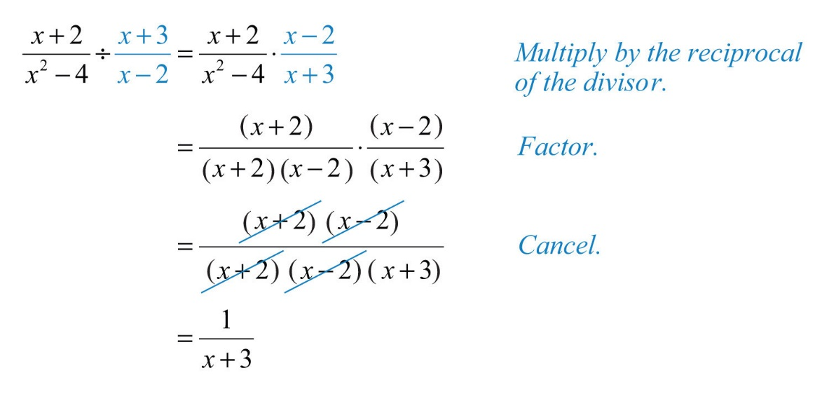
I like how the problem above is re-written as one large fraction, before canceling. This really shows how we only cancel factors.
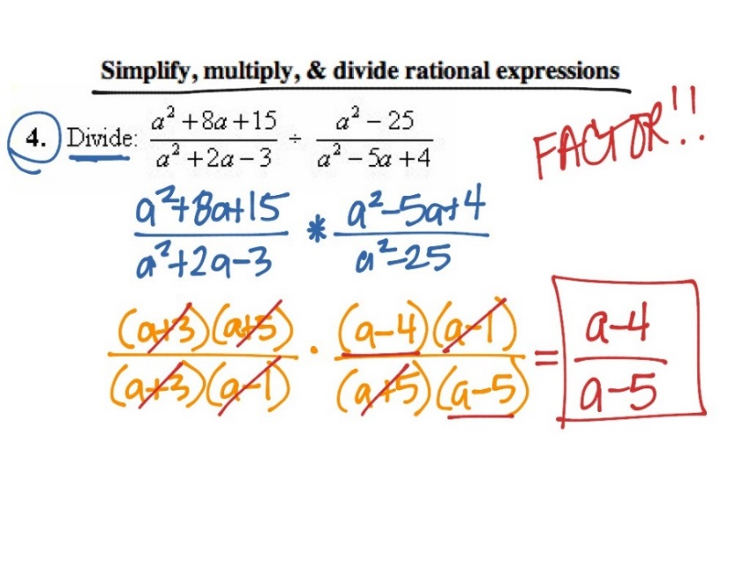
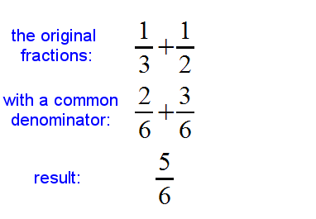
Adding and Subtracting Fractions-L22
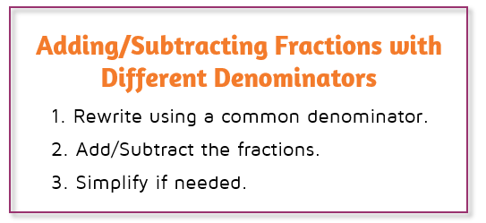
THE LCD-More Complex-Adding and Subtracting Fractions

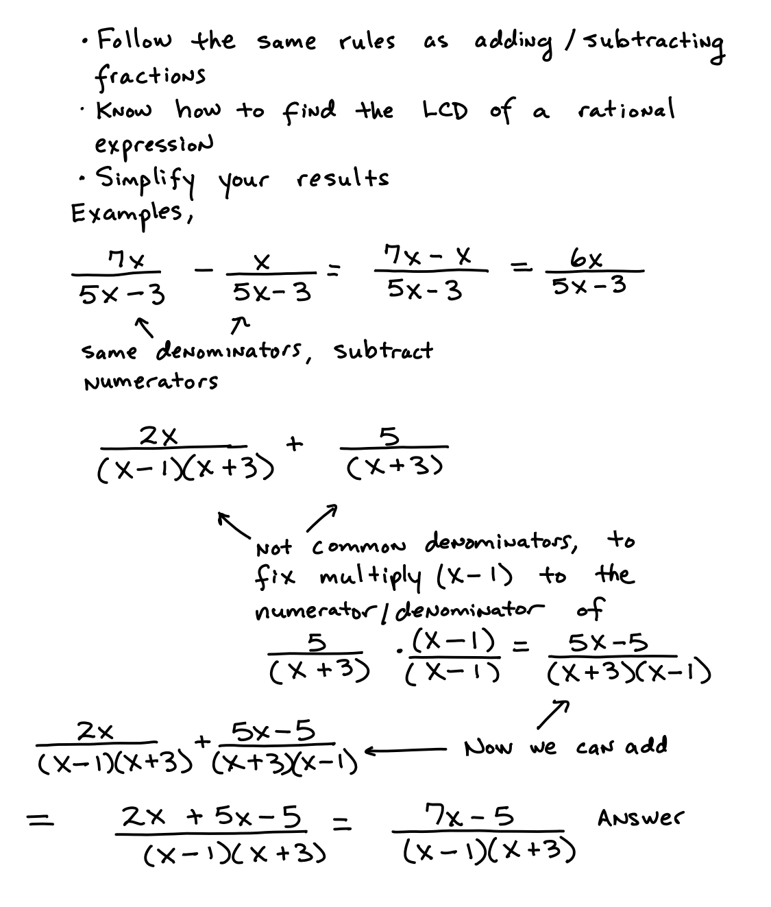
Complex Fractions-L23 A fraction divided by a fraction.
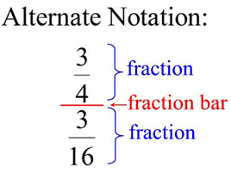

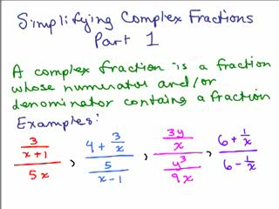

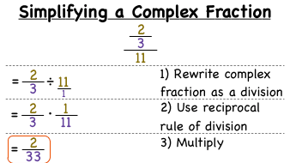

This gets way more difficult, see the notes above on “Multiplying and Dividing Rational Expressions” We need to get used to rewritng division problems as….“Multiply by the reciprocol”

Solving Rational Equations-L24
The problem may say, “Find the roots of…” or, “Solve” or, “Find the solution to…” If we see an equals sign, factor and cancel, but we should probably solve it, don’t stop till you get “ X = something.
(If the variable happens to be X)
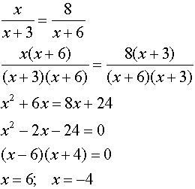
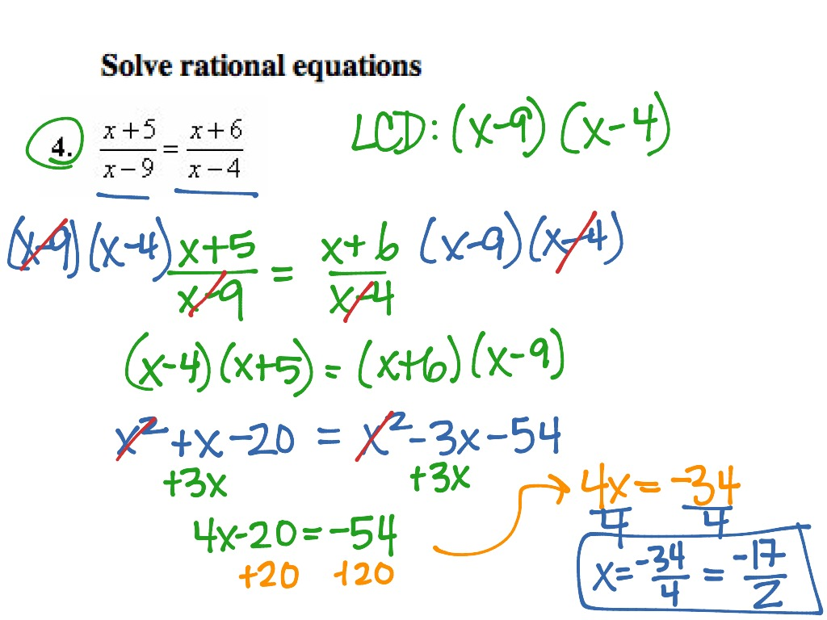

Completing the Square-L25
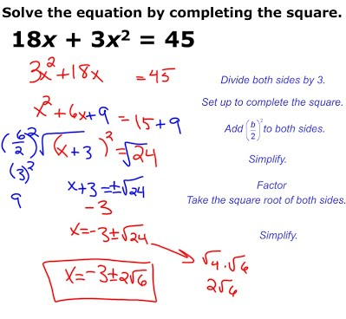
_____________________________________________________________
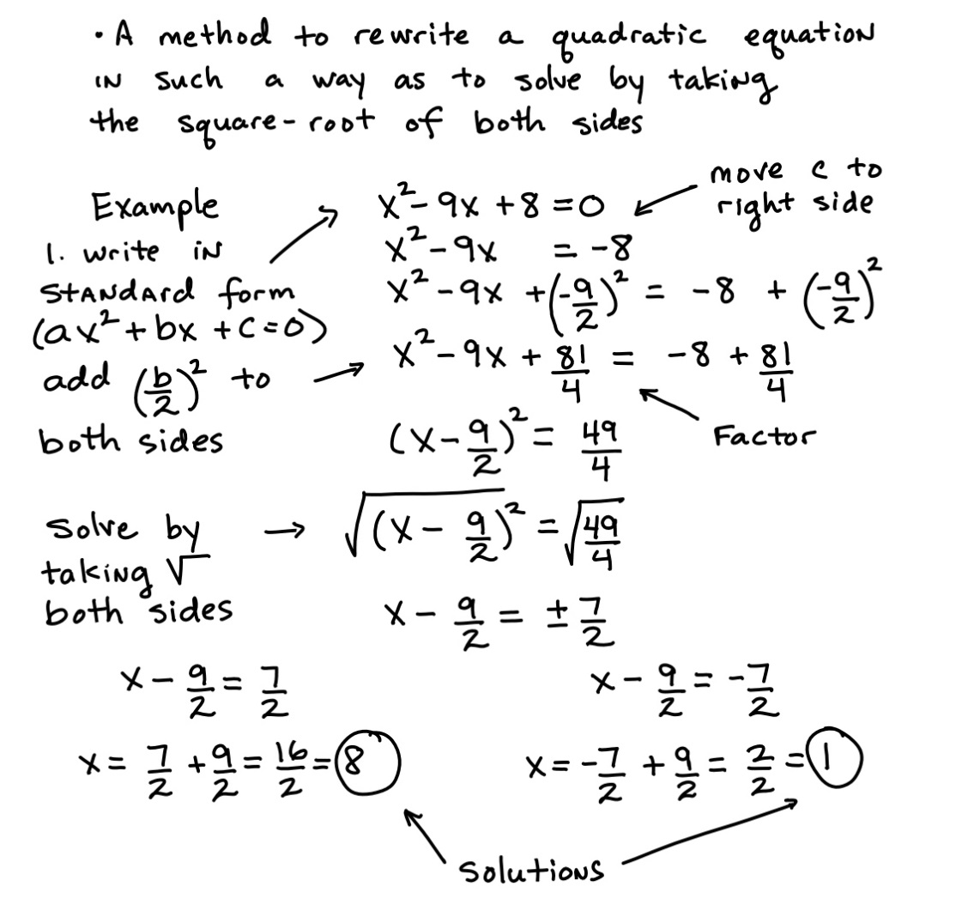
Using The Quadratic Formula-L26
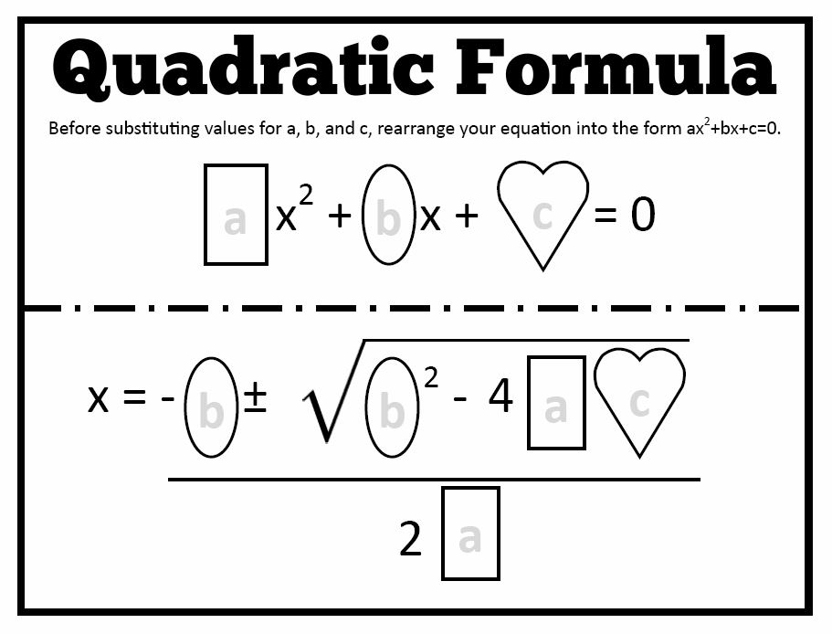
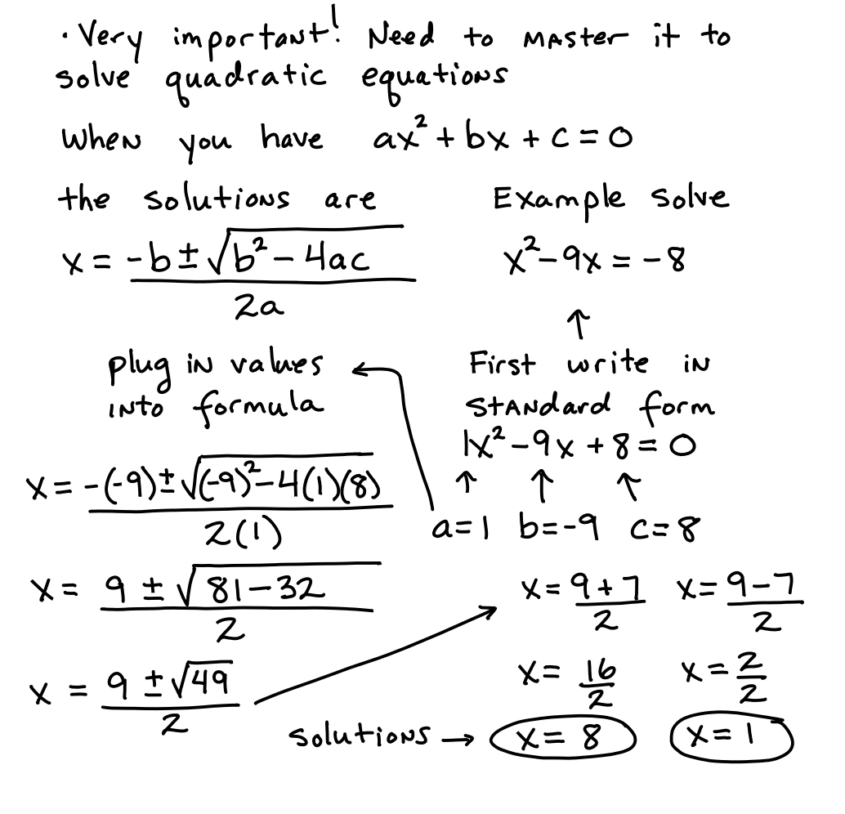
Discriminant-L27
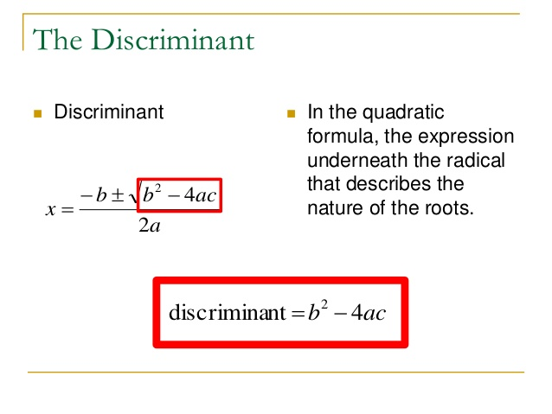
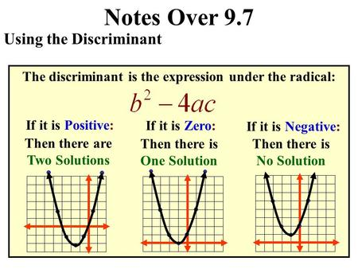
2 Real Solutions 1 Real Solution Imaginary Solution

2 Real Solutions In class we talkd about four scenarios. When the discriminant is Positive we look at whether the number is a perfect square.

Discrimant = A Perfect Square….(E.g., 1, 4, 9, 16…121…)
Then the root are RATIONAL

Discrimant = NOT A Perfect Square….(E.g., 2, 3, 5, 6, 7, 8 ,10, etc,….) Then the rootas are IRRATIONAL
Quadratic Inequalities-L28
What is a quadratic inequality?
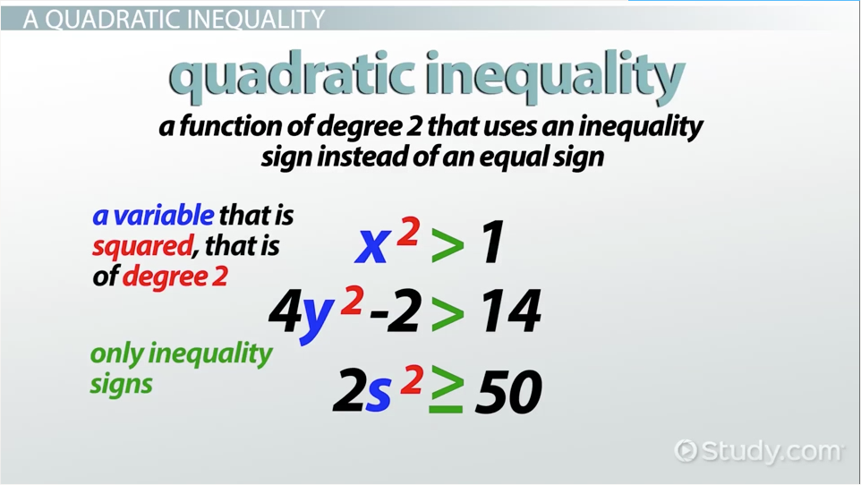
How do we solve quadratic inequalities?
Factor first, the set the inequality equal to zero and

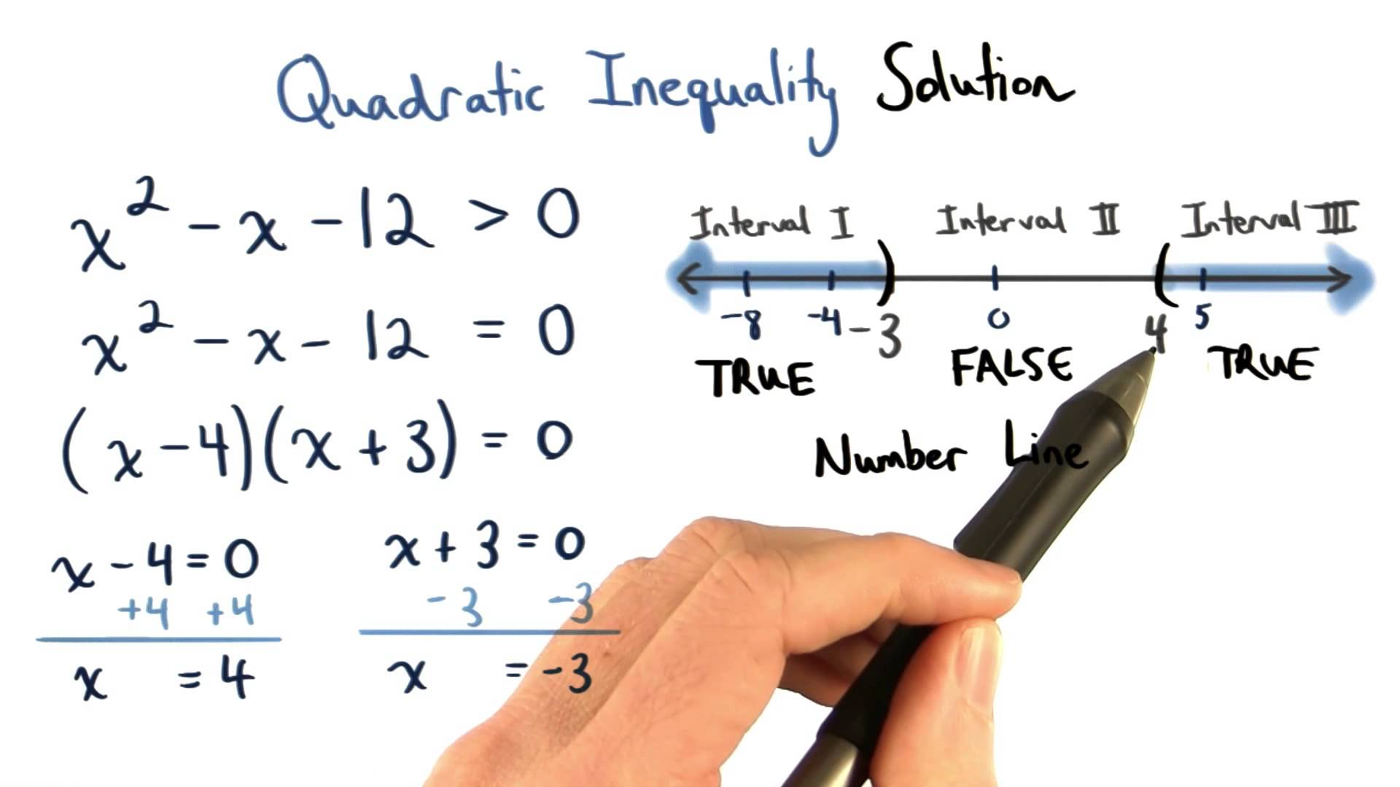

Solving Rational Inequalities-L29

Why is it called a “Rational Inequality?”
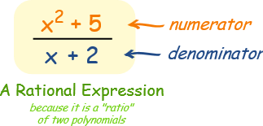
Find Critical Values: We factor first, then find the roots, also know as zeros, also know as critical values. I wish they only had one name :/ We find the roots because that gives us a starting point for graphing. If we know the values of X when Y=0, we know where it will cross the x-axis line.

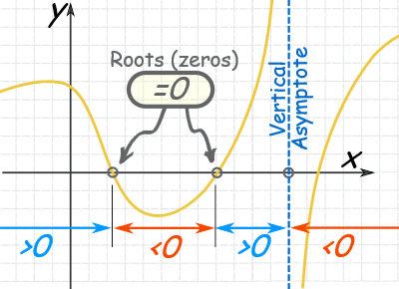
E.g., Find Critical Values: ((X-4)/(X+1)) > 0
The critical values are X=-1, X=4

Start the Graph: After we find the roots, we can begin to graph our line. The graph shows us a visual of all the solutions to the inequality.OPEN CIRCLE FOR DENOMINATOR CRITICAL VALUE . Think about this, we said we can’t divide by zero, we can’t even define it, if we did, we literally call that “undefined.” Since that can never happen, we never actually touch the point
Solving Rational Inequalities-L29 Continued…….
where Y=0 on our graph. It is similar to how we treat infinity, we just continue to approach that point but never actualy attain the value as a solution.

E.g., Graph the Critical Values X=-1, X=4

Draw a number line and place the critical values on the number line in their natural order, least to greatest. Make sure to use an open circle for the critical value(s) found from the denominator.

The other circle(s) will be either open or closed, they depend on the original sign. Our original sign from ((X-4)/(X+1)) > 0, is greater than or equal to, so it gets a closed cirlce.

| |
-1 4
E.g., Draw lines on our graph:

Now we use the sign analysis chart. I figured calling the step “draw lines” is nicer. That’s what we’re doing, we’re looking in the middle spots (test intervals) to see if the statement we’re making is true in that spot, if it’s true, we draw a line. The equation, ((X-4)/(X+1)) > 0 is a statement! We are saying that if we use certain values for “x,” the resulting answer will be greater than or equal to 0. Then we draw a line on the graph where the numbers work, if they don’t work, we don’t color. Meaning, we test and see if the statement we made is true in that spot. We use a sign analysis chart because we are always talking about zero. We only have to

Solving Rational Inequalities-L29 Continued…….
check if it’s positive or negitive because that’s what makes a number greater than or less than zero, the + or – sign.

| |
-1 4
I’ll try: -2 0 5

Sign Analysis Chart
((X-4)/(X+1)) > 0 Again, we want + numbers here
((X-4)/(X+1)) > 0 | ((X-4)/(X+1)) > 0 | ((X-4)/(X+1)) > 0
Will using -2 be + ?  ((-2-4)/(-2+1)) > 0  ((-6)/(-1)) > 0  – divided by – is +  6 > 0  True, 6 is positive, color | Will using 0 be + ?  ((0-4)/(0+1)) > 0  ((-4)/(1)) > 0  – divided by + is -  -4 > 0  False, -4 isn’t greater than or equal to 0, negative, don’t color | Will using 5 be + ?  ((5-4)/(5+1)) > 0  ((1)/(6)) > 0  + divided by + is +  6 > 0  True, positive, color
We finally draw our line(s)…

| |
-1 4
Long Division of Polynomials L30
Steps For Dividing Polynomials
Step 1: | Put the exponents in order. Make sure the polynomial is written in descending order. If any terms are missing, use a zero to fill in the missing term (this will help with the spacing).  E.g., if you see X³ + X⁴ instead write.. X⁴ + X³ , the exponents are in order
Step 2: | Divide the term with the highest power inside the division symbol by the term with the highest power outside the division symbol.
Step 3: | Multiply (or distribute) the answer obtained in the previous step by the divisor (polynomial in front of the division symbol.)
Step 4: | Subtract and bring down the next term.
Step 5: | Repeat Steps 2, 3, and 4 until there are no more terms to bring down.
Step 6: | Write the final answer. The term remaining after the last subtract step is the remainder and must be written as a fraction in the final answer

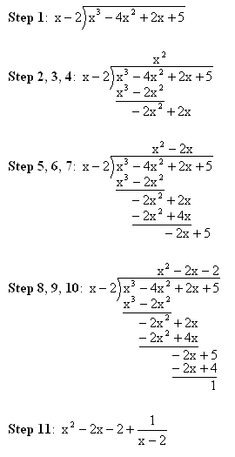
Good Links

Solving Rational Inequalities-L29 Link
Great website with examples and extra problems http://www.mesacc.edu/~scotz47781/mat120/notes/inequalities/rational/rational_inequalities.html

Long Division of Polynomials L30 Link

Great website with examples and extra problems
http://www.mesacc.edu/~scotz47781/mat120/notes/divide_poly/long_division/long_division.html

Extra Notes Spaces

Factor Remainder Theorem L31
I was absent this day but I looked over the notes.
We reviewed L30 and tied in some recall about factors.

Recall:
What’s a factor? Most common student answer I hear: “A number that goes in evenly, no remainder.”

Right!! But it doesn’t have to be a number. We need to broaden our definition and think of a factor as: “A thing that divides evenly, no remainder”

So if these terms, like (X-3) divide the function evenly, with no remainder, then they are factors. Here x – 3 is not a factor.

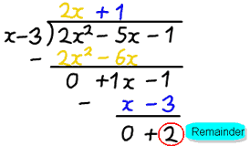

From the factor remainder theorem f(3) = 2, which is true! It works. So it’s just another way of showing equality and how this is all connected.

Solving Higher Degree Polynomials L32

(A.K.A. Solving Functions with an exponent bigger than 2)
When in doubt graph it out, get a visual idea. Use the fabulous tools you have!!! CALCULATOR! Y=…… GRAPH
(Old Lady Voice) When I was in school, we walked up hill both ways..... bicycle wheels were SQUARE! We didn't have TI 84's… Movie suggestion: “Hidden Figures”-Learn to appreciate

What we usually want to know:
- What are the zeros of the function?
- What does the graph of the function look like?

1) What are the zeros of the function?
Zeros or Roots or X-Intercepts or (When Y = 0) or....... The Harsh One: When the ball hits the floor given the graph or equation in which distance is a function of height? UUGGGHHHHhhhhh

Basically, when you see a higher degree polynomial
FIND FACTORS AND SOLVE FOR ZERO .DONE.
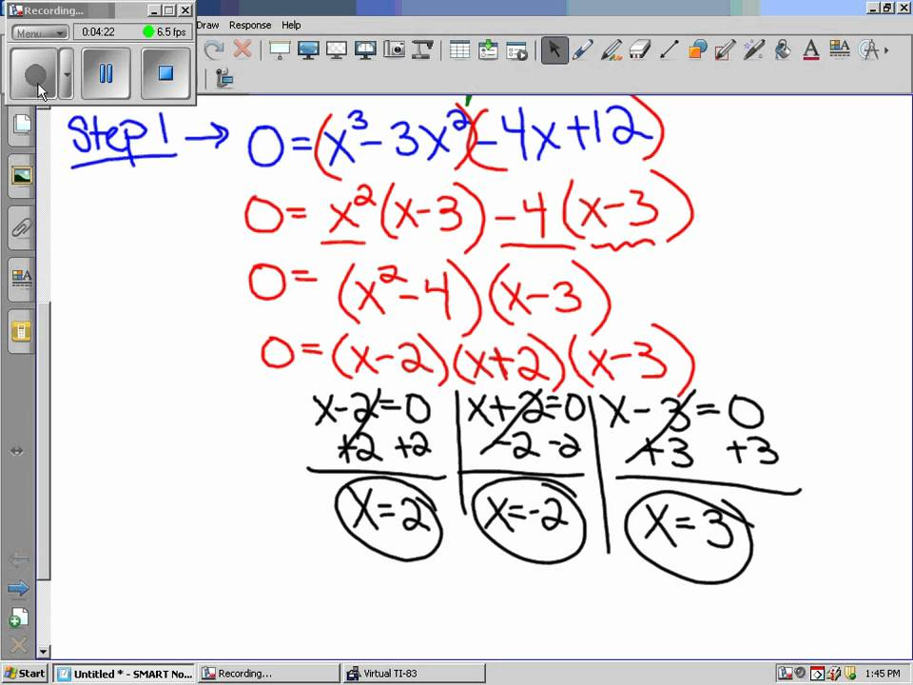

When done, mark these zeros on your graph’s x-axis. Here, we would put points on 2, -2, and 3 on the x-axis

Solving Higher Degree Polynomials L32 Continued….

(A.K.A. Solving Functions with an exponent bigger than 2)
2) What does the graph of the function look like?

Basically, we have 3 scenarios picture wise, it's where the function
Look 1) Crosses (light blue down in our notes L33 12/15)
Look 2) Bounces (red down in our notes L33 12/15) or,
Look 3) Terrace crosses (green down in our notes L33 12/15).
……………………………………………………………………………………………………………………….
Look 1) Crosses
Connection to help you remember why: Functions that have Exponents of 1, and are called linear functions.
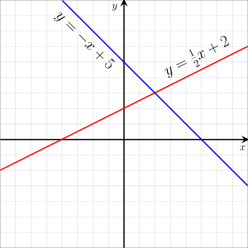These show exponents of 1 for the X variables on both lines
Functions with FACTORS that have an Exponent of 1 go straight and CROSS right through points and axis. Like a line.
Look 1) Crosses, Factored Form with No Exponent, exponent=1:
(x + 1) or (2x -3) or x (all alone, exponent=1)
………………………………………………………………………………………………………………………………………………………………………
Look 2) Bounces, Factored Form with an Even Exponent Bounce.
(x + 1)² or (2x -3)⁴ or x¹⁰³⁸² (it ends in 2, it’s even)
………………………………………………………………………………………………………………………………………………………………………
Look 3) Terrace crosses
Factored forms, an Odd Exponent that isn’t 1 Terrace Cross.
(x + 1)³ or (2x -3)⁵ or x¹⁰³⁸¹ (it ends in 1, it’s odd)
***We would have to do test values next, which we explain in L33. To see where the function begins, the y-intercept is a great point, that is where X = 0. Substitute 0 into the equation for X. OR use your CALCULATOR and LOOK. All of this learning is connected, this is similar to graphing inequalities…look back at L28 and L29 for a better understanding of how it’s all connected ***
Sketching Polynomials L33 We are taking what we learned in L32 Drawing it.
Our class notes were the best examples.
***If the test values, confuse you, the bounce, cross, terrace,.. rely on what you already know, always try to make sense of the problem….
*** Look in your CALCULATOR and graph the points from the table….then connect the dots…..we are sketching graphs….

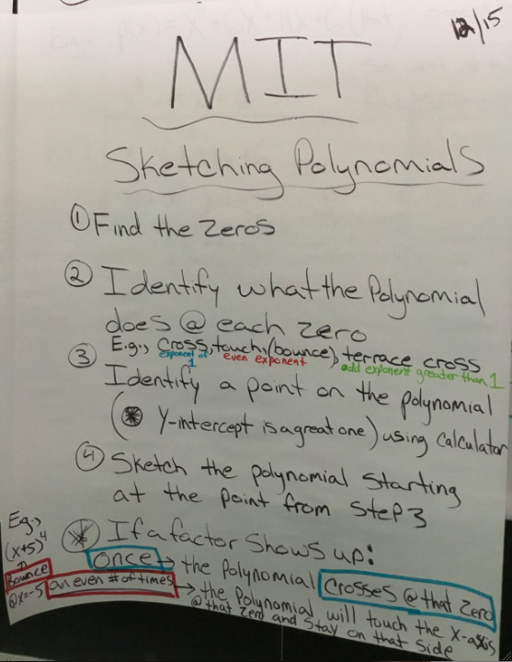

Sketching Polynomials L33 Continued…We are taking what we learned in L32 Drawing it. Our class notes were the best examples.

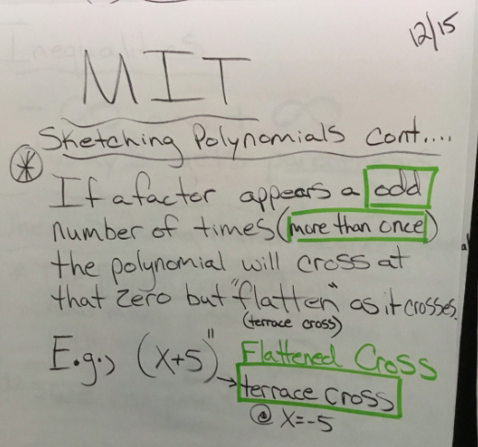

Sketching Polynomials L33 Continued…We are taking what we learned in L32 Drawing it. Our class notes were the best examples.

For this example notice the factors had an exponent of 1, so
Look 1) Crosses, Factored Form with No Exponent, exponent=1:
(x+1)(x -2)(x-4) (all alone, exponent=1)

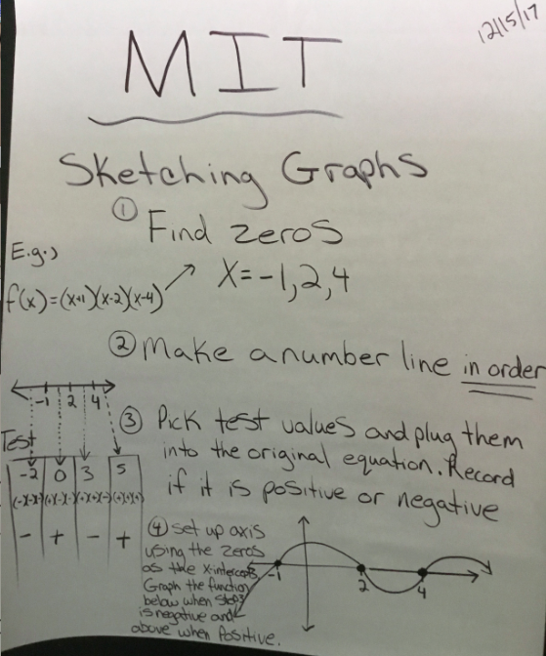

Writing Equations of Polynomials L34
This is working us into real life examples. This topic connects what we know about points and properties of shapes on graphs to writing equations. Our class notes were the best examples.

E.g., 1: Since this is a quadratic, we know they look like: ax² + bx + c, the highest variable is to the 2nd degree. It will have 2 roots, each with exponents of 1

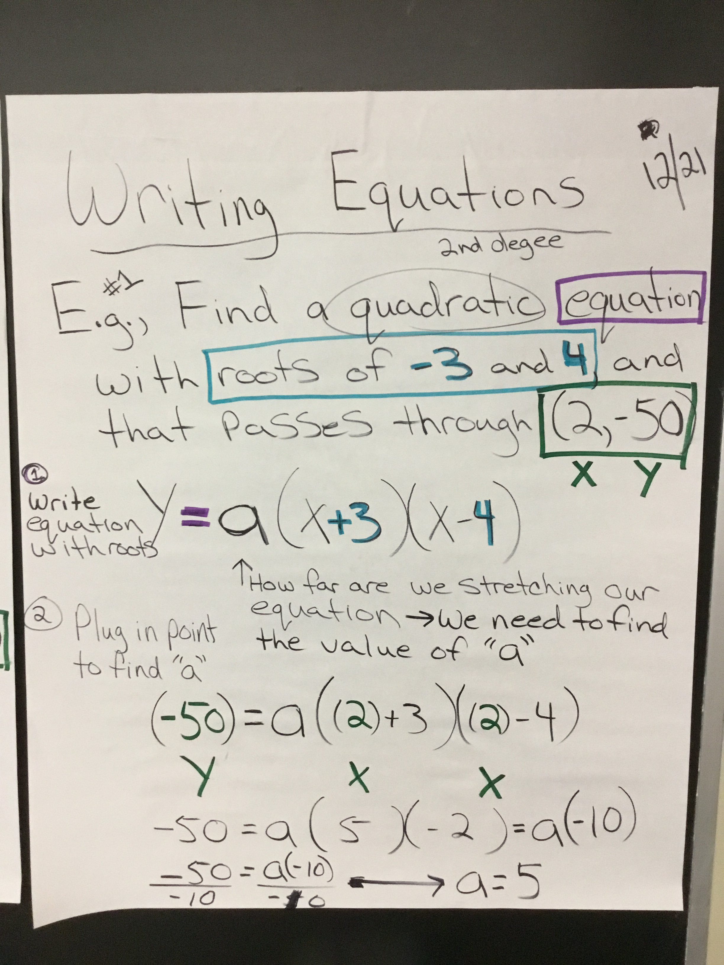

Writing Equations of Polynomials L34 Continued…

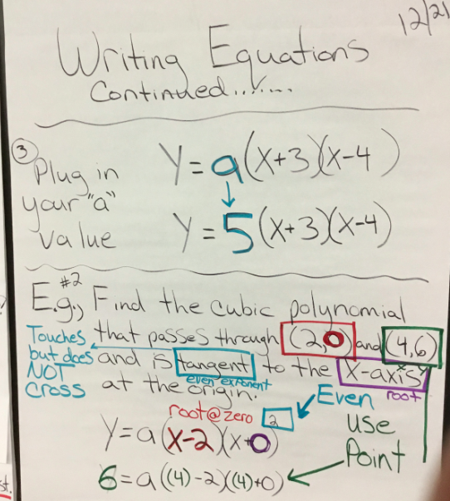
E.g., 2: A Cubic polynomial will have 3 roots and since it says it in tangent, we know that looks like a bounce on a graph and that root will have an even exponent….
It’s hard to study and prepare for these types of questions, but good to review why we did what we did….with each question some new connection might click…
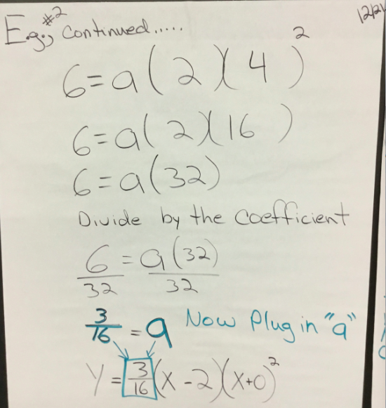

Synthetic Division L 35
This is basically a trick that we can use instead of doing long division. Follow the steps and TRY a few, you’ll get it. It’s faster and easier than long division (L30). You need to try and check your work. This example shows a polynomial being divided by X+3.
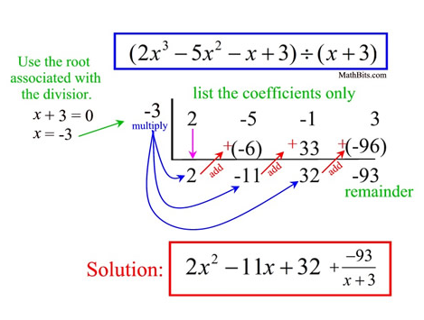
I love this website because they are very clear about each step and have sample solutions!
http://www.mesacc.edu/~scotz47781/mat120/notes/divide_poly/synthetic/synthetic_division.html
Step 1 | To set up the problem, first, set the denominator equal to zero to find the number to put in the division box. Next, make sure the numerator is written in descending order and if any terms are missing you must use a zero to fill in the missing term, finally list only the coefficient in the division problem.
Step 2 | Once the problem is set up correctly, bring the leading coefficient (first number) straight down.
Step 3 | Multiply the number in the division box with the number you brought down and put the result in the next column.
Step 4 | Add the two numbers together and write the result in the bottom of the row.
Step 5 | Repeat steps 3 and 4 until you reach the end of the problem
Step 6 | Write the final answer. The final answer is made up of the numbers in the bottom row with the last number being the remainder and the remainder must be written as a fraction. The variables or x’s start off one power less than the original denominator and go down one with each term.
Circles L36
Equations of a Cirlce: r² = (x-h)² + (y-k)²
Um, where did all of these letters come from!?!? Really!!! Another Formula!! Ugh…Good news. I think I can help this make sense so we remember it.

1) First we have to think of the center as (h,k)
Why?, “Someone said so..” (I hate that reason) But no, they defined it, we call it (h,k), and h =x, and k=y when we are talking points

Then, think back and look for connections. The distance formula…
PPssst… It’s the same formula, but instead of “distance” it’s “radius”

The Distance Formula IS The Equation of a Circle
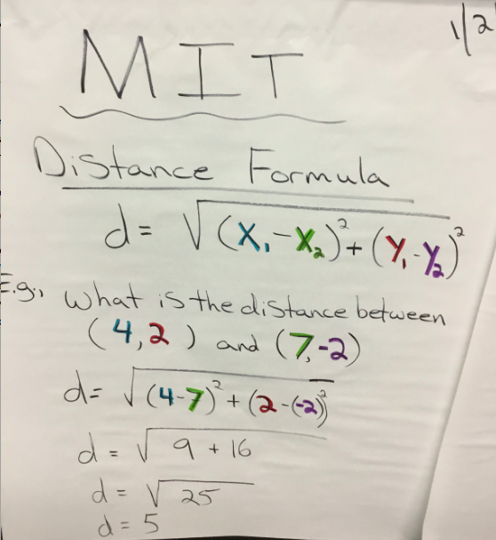= 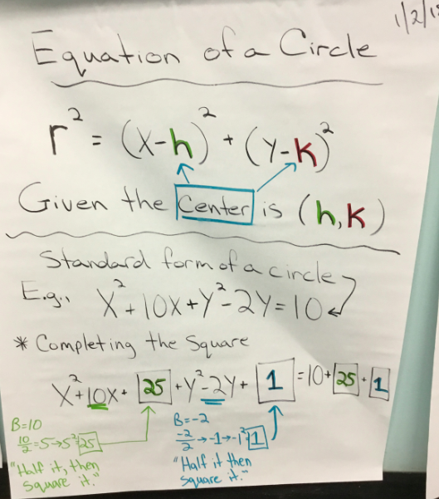

LOOK and THINK and CONNECT
circle equation r² = (x-h)² + (y-k)²

If we take the square root of both side, we would get the distance formula, which comes from the pythagorean theorem,….it’s all connected, I love math!!

Circles L36 Continued…
Here is a nice example of how when we check a circle with a center at the orginin, (0,0), then we would get the pythagorean theorem…

Pythagorean Therorem (That Triangle) + The Distance Formula

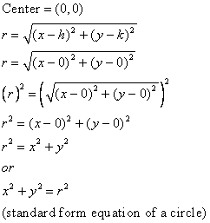

It looks like a² + b² = c² now. I hope you can see the connection so it doesn’t feel like a new formula as much. In any case, most problems give us two points, and want us to find the radius (aka distance). Or, they give us the center point and another point and want us to find the radius, so we substitute in h, and k, and work from there.
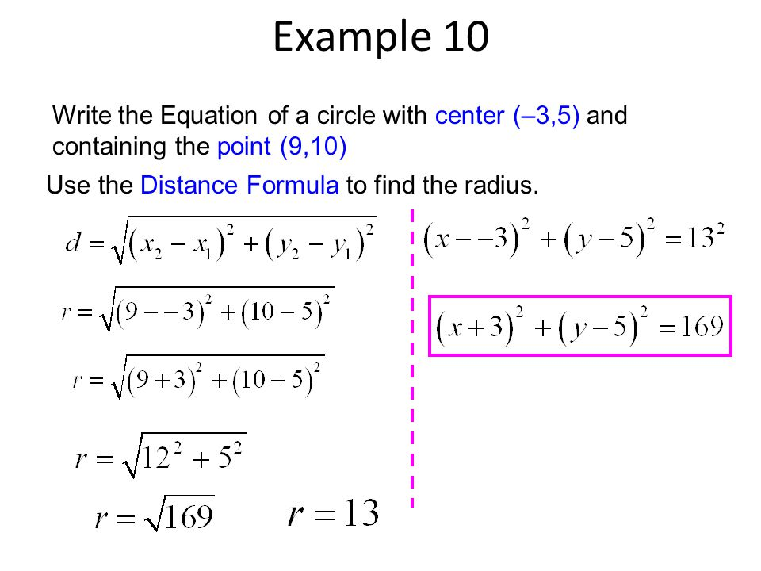
Intro to Functions L37

We talked about what functions were this day and reviewed some stuff from Algebra 1. Like how for every input there is only one output in a functions. The vertical line test.. THEY ARE CURVEY. Draw them curvey

The “New” idea here is that functions can be special, they can be “One to One,” which means there is also one input for every output. BOTH the vertical and horizontal line tests would work.
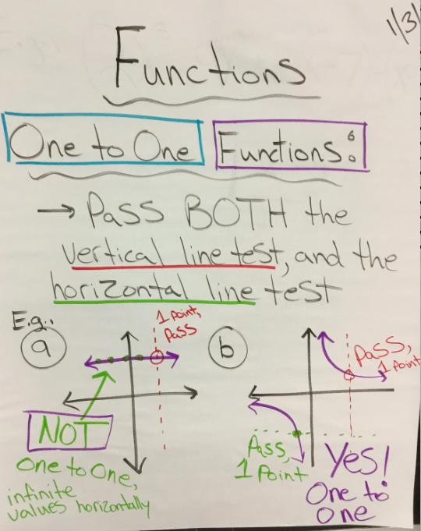

Function Notation L38
More review of Algebra 1. We talked about how we evaluate functions for specific values. This was to lead us into compositions. I displayed this one because it is a little harder since they didn’t just give us a number to evaluate. Here we are evaluating x+1 . 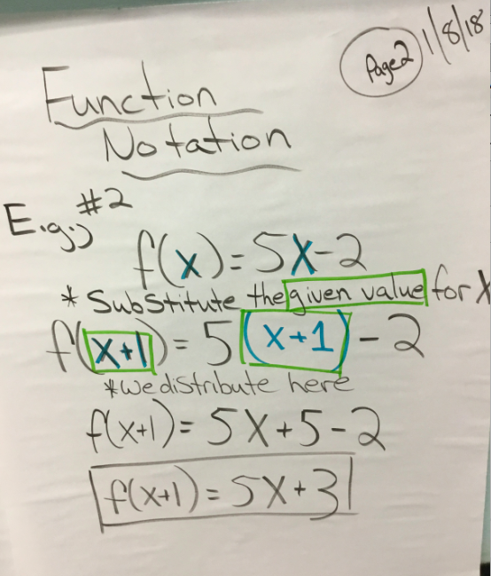

Domain and Range of Functions L39
This seems to be a big part of the review packet so try to really understand this. Let’s start with the talk….we need to know what (Vocab.) they are even asking! Also, we need to know Notation.

Vocab.
Line: So conceptually, in math, a line is really just an infinite set of points all squished and they appear, to our simple eyes, like a line. So these “functions” we are graphing are just squiggly lines.

Domain = all the POSSIBLE X values. (all the X points)
Range = all the POSSIBLE Y values. (all the Y points)

Notation: Is it POSSIBLE to touch that point?
Parenthesis: We use panthesis in three cases.
- When it doesn’t touch that point. Look closely at example 6 below where x = - 4, and x = 1. Those circles are NOT colored in. It’s not touching that exact point.
- If it is NOT POSSIBLE to touch that point. For example infinity, we can’t ever get there conceptually. If these graphs had ARROWS that means INIFINITY, that means PARENTHESIS.
- UNDEFINED: If the function is a fraction, with a variable we can’t touch that point where the denominator = 0.
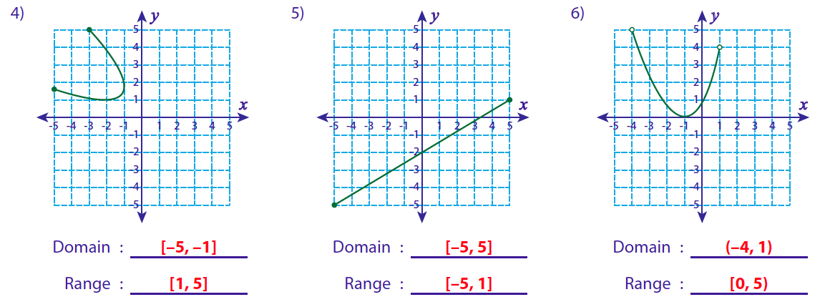

Domain Algebraically L40

Algebraically, just means with letters and numbers and symbols. So these will be examples with points and not graphs.
***I’d assume they might ask, 1, if these are functions? And, 2, are they One to One?*** So ask yourself that as you look at the examples. I wrote the answers to 1-3 below.

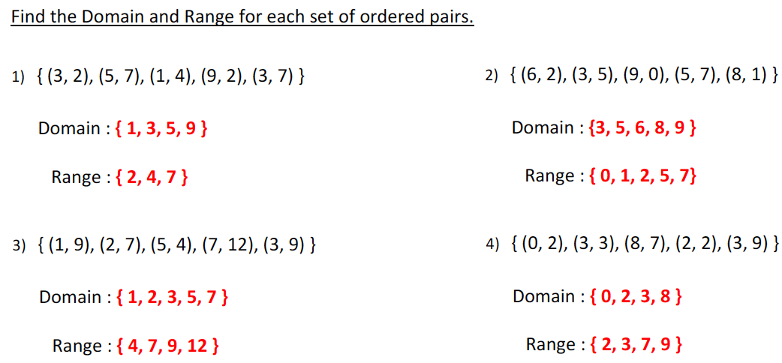

#1
- Are these are functions?
  - No, there are two “3” values
- If so, 2, are they One to One?
  - Impossible, it can’t be One to One if it’s not even a function
#2
- Are these are functions?
  - Yep, no repeating X values. This is a function.
- If so, 2, are they One to One?
  - Yep, no repeating Y values EITHER! What a special function! (Corny works for me -Ms. B.)
#3
- Are these are functions?
  - Yep, no repeating X values. This is a function.
- If so, 2, are they One to One?
  - Nope, the “9” repeats, not so special Sad function.

Composition of Functions L41
These may be more understandable if you think about it like pemdas.
If we had 7 ( 2 + 3 ), this is asking, hey, what’s 2+3 first? We would find 2+3, then evaluate, 7 (that answer).
Functions say the same thing, f ( g(x) ), this is asking, hey, what’s g(x) first? We would find g(x), then evaluate, f (that answer).
Math Statement Example: “I’m going to the dryer (D) to get my launrdy (L) that I obviously, already put into the wash (W).” D ( W ( L ) )
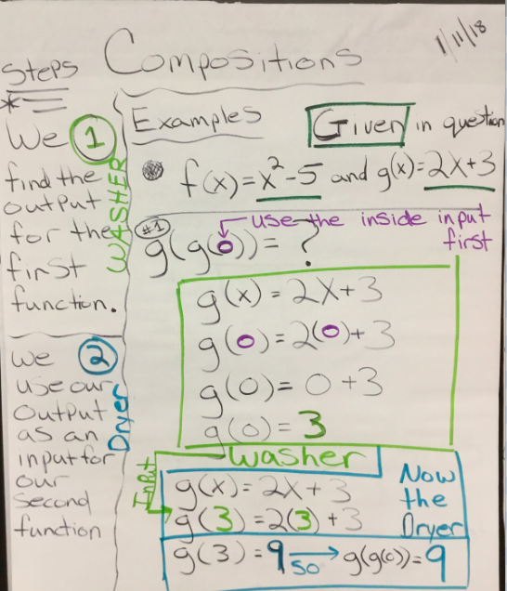

Composition of Functions L41 Continued…
Real Life Example….
